**Creating Inclusive Holiday Experiences for those with Vision Loss**

The holiday season is a time of joy, togetherness, and celebration. However, for individuals who are blind, have low vision, or are part of the deafblind community, traditional holiday activities can sometimes present challenges. By incorporating thoughtful accessibility measures, we can ensure that everyone can fully enjoy the festivities.

**1. Accessible Decorations and Displays**

Holiday decorations often rely on visual appeal. Adding tactile and auditory elements can make them more inclusive:

* **Tactile Displays**: Use textured ornaments, wreaths, or decorations that can be explored by touch.
* **Auditory Enhancements**: Include sound-based decorations such as musical ornaments, wind chimes, or holiday songs triggered by motion sensors.
* **Scented Elements**: Incorporate holiday-themed scents like pine, cinnamon, or peppermint to evoke the holiday spirit.

**2. Inclusive Holiday Gatherings**

Social events are a hallmark of the holidays, and making gatherings accessible ensures all guests feel welcome.

* **Clear Communication**: Use large print or braille for invitations and menus.
  + If you cannot provide braille or large print, be sure to be available to read items to your guest.
  + Ensure efforts are made to include the blind individual in the gathering to prevent them from being left sitting alone for extended periods
* **Orientation Support**: Provide a guided walkthrough of the event space or ensure furniture placement is consistent and unobstructed.
* **Assistive Technology**: Have devices like screen readers or braille displays available if digital resources are used during the event.

**3. Accessible Holiday Shopping**

Gift shopping can be overwhelming, especially when stores lack accessibility features.

* **Shopping Assistance**: Offer personal shoppers who are trained in guiding and describing products.
* **Accessible Websites**: Advocate for e-commerce platforms to have screen reader compatibility and descriptive product details.
* **Gift Suggestions**: Encourage gifts that prioritize accessibility, like tactile games, audio devices, or braille books.

**4. Thoughtful Gift-Giving**

When choosing gifts, consider the recipient's preferences and needs:

* **Audio Descriptions**: Add audio notes or descriptions to gifts, such as recorded messages.
* **Subscription Services**: Services offering audiobooks, music, or tactile art kits can be delightful gifts.
* **Personalized Experiences**: Give the gift of an experience, like a sensory-friendly concert or tactile art class.

**5. Community Involvement and Advocacy**

The holidays are a wonderful time to promote accessibility awareness:

* **Volunteer Efforts**: Organize accessible holiday activities such as sensory-friendly caroling or adaptive sports.
* **Workshops**: Host sessions on creating accessible decorations, gifts, or recipes.
* **Community Outreach**: Collaborate with local businesses and organizations to improve holiday accessibility initiatives.

**6. Celebrating Traditions Inclusively**

Holiday traditions can be adapted to ensure inclusivity:

* **Audio and Tactile Adaptations**: Provide tactile Advent calendars or audio storytelling of classic holiday tales.
* **Accessible Baking**: Use tactile markers or adaptive kitchen tools for holiday cooking activities.
* **Interactive Participation**: Engage everyone in sensory-rich activities like decorating cookies, crafting ornaments, or creating music.

Creating an accessible holiday season for the blind, low vision, and deafblind communities is not just about accommodations, it is about fostering inclusion, understanding, and celebration. By prioritizing accessibility, we make the season brighter for everyone, reminding us of the true spirit of the holidays: togetherness and joy.

Let’s work together to ensure the holidays are a buffet of choices for all, just like our theme for the 2024 PCB Conference and Convention.

Happy Holidays from Everyone at PCB!

**PCB Reflects on the Success of Its 2024 Conference and Convention**

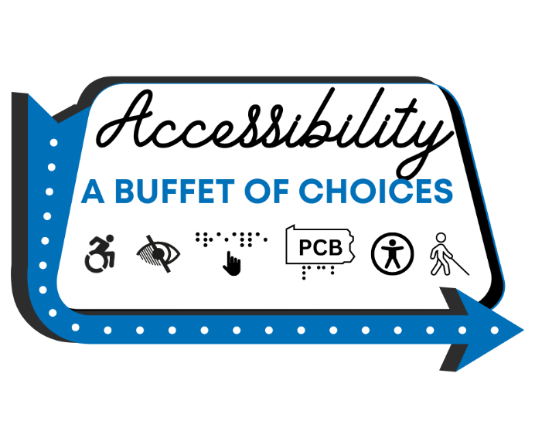In October 2024, the Pennsylvania Council of the Blind (PCB) proudly hosted its annual conference and convention, **"Accessibility: A Buffet of Choices."** Held as a virtual event, this year’s gathering exemplified inclusivity, innovation, and community spirit. Attendees from across Pennsylvania and beyond came together to share ideas, learn, and celebrate the strides being made toward a more accessible world for individuals who are blind, have low vision, or are deafblind.

With a robust lineup of workshops, discussions, and performances, this year’s event offered something for everyone. Here’s a recap of some of the most impactful sessions and activities that made this conference a resounding success.

**Key Workshops and Sessions**

**Creating Accessible Environments for the Blind and Visually Impaired**  
Presented by **Darren Gladstone,** he led a thought-provoking session on the challenges of making physical spaces more navigable for individuals with visual impairments. He highlighted the transformative potential of the **RightHear audio format signage system**, a tool designed to provide audio navigation and contextual information in buildings. Attendees left inspired to advocate for this technology in their local communities.

**Coming Out of the Dark: Emergency Preparedness for Those Who Are Blind, Low Vision, and Deafblind**  
Emergency preparedness expert **Valerie Claire Haven** delivered a vital workshop focused on equipping individuals with tools and strategies to stay safe during crises. From understanding first responders’ training to making pre-crisis decisions, this session empowered participants with actionable steps and resource recommendations to increase safety and resilience during disasters.

**High Tech, Low Tech, and No Tech: Strategies for Self-Communication**  
In this interactive session, **Doug Hunsinger and the PCB Communications Team** explored methods for managing personal tasks such as creating reminders, making grocery lists, and scheduling appointments. Using a mix of high-tech, low-tech, and no-tech solutions, the panel shared insights and encouraged audience participation, fostering a collaborative exchange of ideas.

**Accessible Appliances: A Buffet of Choices**  
Led by **Joe Fagnani and the PCB Technical Access Team**, this workshop showcased the growing array of accessible household appliances. From tactile kitchen tools to voice-controlled devices, attendees discovered how technology is broadening their options for independent living.

**Caring for Pets When You Have Limited or No Vision**

Presented by Debby Hill and Dr. DeAnna Moore, this session provided practical tips on pet care for those with low or no vision, including feeding, grooming, and handling medical needs. An interactive discussion allowed attendees to share personal strategies and solutions, making it an engaging and supportive experience.

**Achieve Greater Independence with the Meta Ray-Ban Smart Glasses**

Lisa Salinger introduced attendees to the features of the Meta Ray-Ban Smart Glasses, highlighting their potential to assist with navigation, information access, and hands-free tasks. The session balanced a demonstration of their capabilities with an honest look at limitations like battery life and cost.

**Performance: Jason Castonguay**  
Following the banquet, award-winning musician **Jason Castonguay** delivered a captivating musical performance and shared insights into making audio engineering accessible for individuals who are blind or have low vision. His presentation inspired attendees with practical strategies and a reminder of the power of creativity.

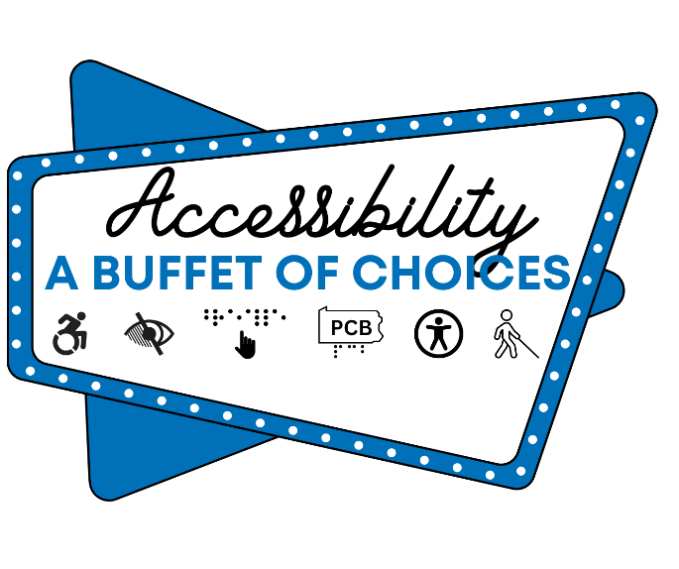**Audio-Described Play: *To See or Not to See***  
A powerful and moving production from Canada’s **VocalEye**, this play explored the journey of a blind woman confronting her past to overcome trauma and societal barriers. Featuring live audio description, the play deeply resonated with attendees, blending moments of humor with poignant storytelling.

**A Celebration of Community and Progress** The 2024 conference was not just about learning; it was a celebration of connection and shared purpose. Networking opportunities, exhibitor showcases, door prizes, casual conversations and our annual PCB fundraising auction reinforced the importance of coming together as a community.

PCB would like to thank all the speakers, performers, volunteers, and attendees who made this year’s event such a success. Your passion and participation embody our commitment to creating an accessible world where everyone can thrive.

As we look ahead to the next year, PCB invites everyone to continue the conversation, share feedback, and join us in championing accessibility as a buffet of choices for all.

**Together, we are stronger. Together, we are building a brighter, more inclusive future.**

***Community Outreach***

**PCB Celebrates White Cane Day 2024: Advocacy and Awareness in Action**

On Tuesday, October 15, the Pennsylvania Council of the Blind joined communities nationwide in celebrating White Cane Day, a day dedicated to promoting awareness of the white cane as a symbol of independence for individuals who are blind or visually impaired. This year, PCB partnered with the Golden Triangle Council of the Blind (GTCB) and the Bureau of Blindness and Visual Services (BBVS) to host a dynamic, community-centered event in Downtown Pittsburgh’s Market Square.

**Student Advocacy in Action**

Middle and high school students, accompanied by their orientation and mobility instructors, played a central role in this year’s celebration. Equipped with their white canes and a passion for advocacy, these students distributed copies of the Pennsylvania White Cane Law to passersby, educating the public about the rights and safety of white cane users.

This hands-on activity gave students a platform to practice their advocacy skills, engage with the public, and take pride in their independence and mobility tools. The bustling Market Square served as the perfect backdrop for spreading awareness and fostering meaningful conversations about accessibility.

In addition to the in-person event, PCB launched a statewide media campaign to amplify the message of White Cane Day:

* Radio PSAs: Pre-recorded segments aired across Pennsylvania radio stations to educate drivers about their responsibilities when encountering pedestrians using white canes or guide dogs.
* Press Releases: Distributed to media outlets, these releases reinforced the importance of driver awareness and compliance with the White Cane Law to ensure the safety of blind and visually impaired individuals.

**A Day of Empowerment and Education**

White Cane Day 2024 was a resounding success, blending public education with empowerment for the next generation of advocates. PCB extends its gratitude to GTCB, BBVS, the students, and their instructors for their commitment to raising awareness and promoting accessibility.

As PCB continues its mission, we invite everyone to honor the significance of the white cane, not just on White Cane Day, but every day, by advocating for inclusion, safety, and respect for all. Together, we are shaping a world where independence and mobility are celebrated!

**Fast Fact**

****According to the CDC, around 12 million Americans aged 40 and older experience vision impairment, including 1 million who are blind, with the number expected to significantly increase due to an aging population. Most individuals who lose their eyesight later in life cannot read braille, instead relying on other means of accessibility including screen readers and magnifiers.

**PCB Joins the Fight Against Vision Loss at the 2024 VisionWalks**

This October, the Pennsylvania Council of the Blind (PCB) proudly participated in the 2024 VisionWalks hosted by the Foundation Fighting Blindness in Pittsburgh and Philadelphia. These inspiring events brought together individuals, families, and organizations to support groundbreaking research and resources for those affected by vision loss.

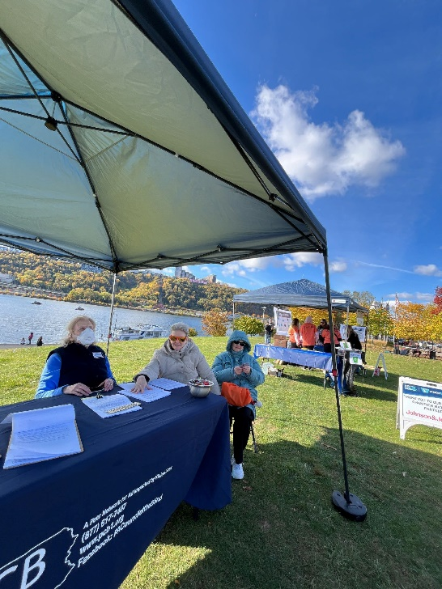**Pittsburgh VisionWalk: October 26, 2024**

On a crisp fall morning, PCB members stepped out in support of a brighter, more accessible future at the Pittsburgh VisionWalk. Alongside an energized crowd of supporters, PCB celebrated a day of awareness, advocacy, and community unity.

Our PCB peers played a vital role, manning the PCB resource table to share information, answer questions, and connect with attendees. From walking the route to engaging with the community, our peers demonstrated the power of collective action in creating change.

Thank you to everyone who joined, donated, or cheered us on in Pittsburgh, your enthusiasm drives progress and inspires hope!

**Philadelphia VisionWalk: October 5, 2024**

Earlier in the month, PCB joined the 18th Annual Philadelphia VisionWalk, a joyful day filled with celebration and purpose. Attendees gathered under sunny skies to recognize the incredible efforts of teams and individuals who raised funds to support the Foundation Fighting Blindness.

The day’s festivities reflected the community’s unwavering commitment to advancing research and resources for vision loss. PCB was thrilled to be part of such an uplifting event, and we extend our heartfelt thanks to everyone who participated.

**Making a Difference Together**

Participating in both VisionWalks was a meaningful reminder of the strength in community and the importance of working together to combat the challenges of vision loss. PCB is proud to stand with the Foundation Fighting Blindness in their mission to fund innovative research and support individuals with vision impairments.

Stay tuned for more events and opportunities to join PCB in advocating for accessibility and independence. Together, we are paving the way for a future where vision loss never limits opportunity.

**Peer Spotlight**

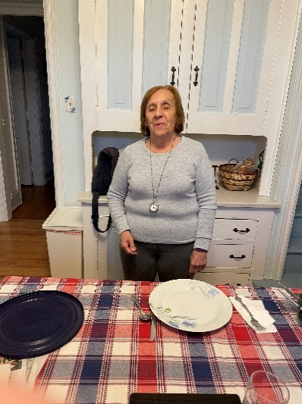The PA Council of the Blind is beyond excited to celebrate our 2024 Award Winners!

**Bette Homer: 2024 John A. Horst Champion of Independence Award Winner**

This prestigious honor recognizes an individual who has dedicated over 20 years to advancing independence, opportunity, and empowerment for individuals who are blind or visually impaired. Bette Homer’s unwavering commitment to rehabilitation, education, advocacy, and public awareness has made a lasting impact, not just in her local community, but across the state and nation.

Through her tireless efforts, Bette has transformed lives, broken barriers, and inspired countless individuals to embrace their full potential.

**Sue Lichtenfel: 2024 Anthony B. Swartz PCB Peer Excellence Award Winne****r**

Sue’s dedication spans over 10 years of volunteer service, leadership, and unwavering commitment to PCB’s mission and community. From championing events and projects to supporting her peers, Sue exemplifies the true spirit of excellence and service.

Thank you, Sue, for your inspiring contributions and for going above and beyond to make PCB stronger and more inclusive!